# Create a Pub/Sub using the Google Cloud Console.

Create a Pub/Sub topic

Login with your google credentials and go to the Pub/Sub topics page in the Cloud - <https://console.cloud.google.com/cloudpubsub/topicList>

The Google Cloud Platform Pub/Sub listing page will be loaded.

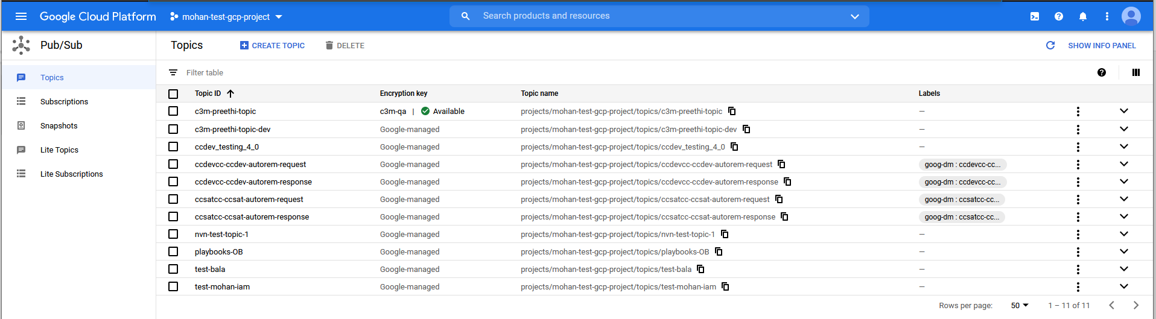

Click on **Create a topic**. (at the top of the page)



Create a topic window will pop-up. In the **Topic ID** field, provide a unique topic name

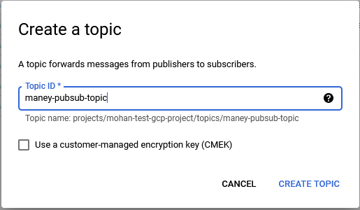

Click on **Create Topic** button. Once you click, Google will take about 5 seconds to load the newly created **Pub/Sub Topic Details** page.

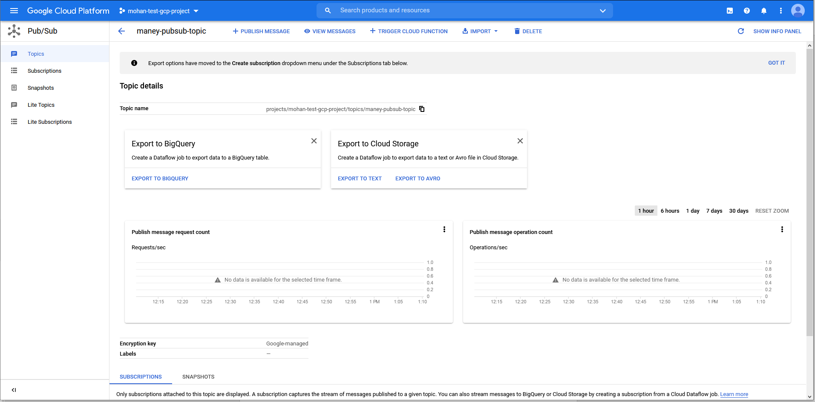

We have just created a Pub/Sub topic!

We shall create a sink and configure the topic created to receive the events.

On the top of the screen, click on **Activate Cloud Shell**.



You will see a Cloud Shell Terminal at the bottom of the page. This will take about a minute to open.

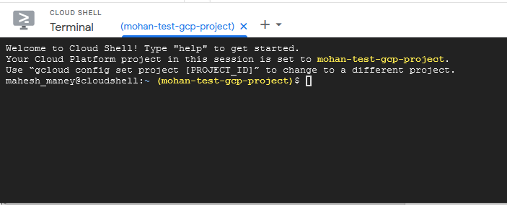

Sink can be created for an ORGANISATION or a FOLDER level. To create a sink at

Folder Level:

**$ *gcloud logging sinks create {sink-name} pubsub.googleapis.com/projects/{project-id}/topics/{topic-name} --organization={organization-id} --log-filter="protoPayload.@type=\"type.googleapis.com/google.cloud.audit.AuditLog\""***

You may replace {sink-name} with your desired sink-name, {project-id} with project-id, {topic-name} with the newly created topic-name and {organization-id} with organisation-id.

Organisation Level:

**$ *gcloud logging sinks create {sink-name} pubsub.googleapis.com/projects/{project-id}/topics/{topic-name} --folder={folder-id} --log-filter="protoPayload.@type=\"type.googleapis.com/google.cloud.audit.AuditLog\""***

You may replace {sink-name} with your desired sink-name, {project-id} with project-id, {topic-name} with the newly created topic-name and {folder-id} with folder-id.

Remember to grant

*serviceAccount:f320096202181-349198@gcp-sa-logging.iam.gserviceaccount.com*

the Pub/Sub Publisher role on the topic created.

On execution of the above commands, you will see a message (successful) like;

**Created [**[**https://logging.googleapis.com/v2/folders/320096202181/sinks/{topic-name}].**](https://logging.googleapis.com/v2/folders/320096202181/sinks/%7btopic-name%7d%5d.)

Example :

**Created [**[**https://logging.googleapis.com/v2/folders/320096202181/sinks/maney-pubsub-topic].**](https://logging.googleapis.com/v2/folders/320096202181/sinks/maney-pubsub-topic%5d.)

## Configuring the newly created Pub/Sub topic in CCQA app

Login to - <https://ccdev.c3m.app>

Navigate to **Administration** –> **Platform Settings**

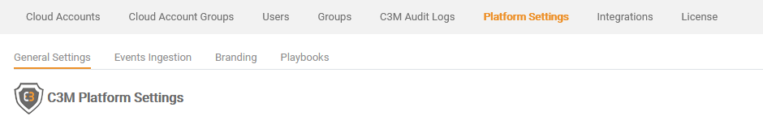

Click on **Events Ingestion**

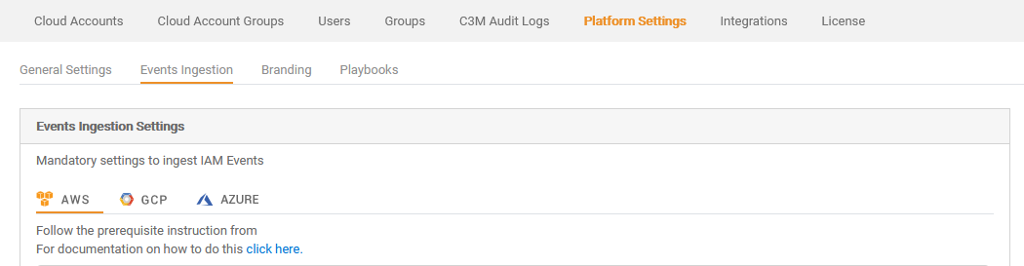

Choose **GCP**

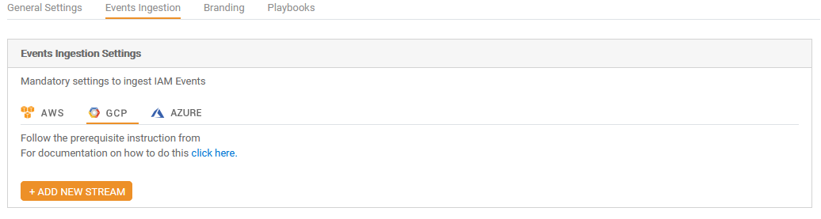

Click on **ADD NEW STREAM**

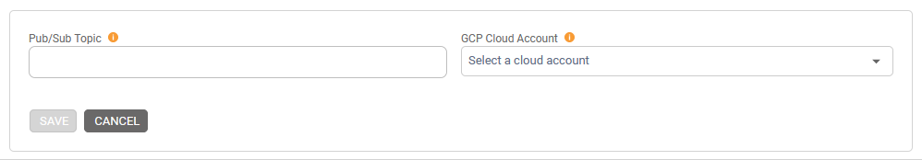

Enter the newly created Pub/Sub topic and choose the GCP Account

Click on Save.

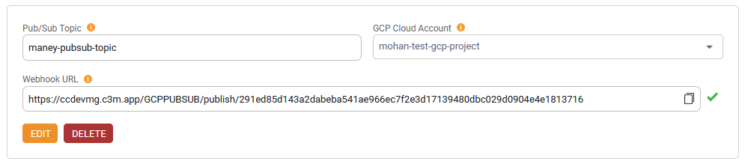

A new webhook URL is generated and saved in the system.